ACRA VIC Branch Seminar: Building Defects
Your speakers for this evening seminar are:
Dr Nicole Johnston from Deakin University, Dr Johnston will be speaking on suggested examinations of building defects in residential multi-owned properties [legal perspective].
Dr Johnston recently held this talk for ACRA NSW, and not only did she present to a packed room but had people discussing her Building Defects Research report for weeks after this seminar.

Lorian Fosdick from Watertite, his role is a waterproofing design and compliance consultant for Tier 1 builders in the construction industry.
This involves the analyse of project documents, research and stakeholder consultation, technical submissions and report recommendations to the clients to achieve best value practices and outcomes for the project, along with planning for high-risk avoidance. Essentially advising where we can get it right on the project to avoid future costly defects.
Lorian will present on waterproofing/building defect causes, substrate requirements, and corrective measures.

The VIC Branch of ACRA welcome all interested professionals in the field of concrete repair/remediation to our seminar.

This seminar will interest students, strata, structural owners, consultants, engineers, suppliers and contractors on the available technology and advancement with concrete repair, this seminar will be very educational and will provide attendees with a wealth of knowledge in your unique field.

Seminar: Tuesday 31 March 2020 Time: 5:45pm – 8.30pm Venue: Quay West Suites Melbourne 26 Southgate Ave, Southbank VIC 3006 Cost: $55 for ACRA Members $77 for Non-Members

Event Registration Form

Company Name:
www.
Name:
 |  | First Name |  |  |  |  | Last Name
Phone:
Email:
Name:
 |  | First Name |  |  |  |  |  | Last Name
Phone:
Email:
Name:
 |  | First Name |  |  |  |  |  | Last name
Phone:
Email:
Member Rate: ☐ |  |  |  | $55.00 pp |  |  |  | Total $
Non-Member Rate: ☐ |  |  |  | $77.00 pp |  |  |  | Total $
☐ Please invoice for VIC Melbourne 31 March 2020
To pay via credit card, please complete the section below or phone +61 2 9645 3692
Charge $ ___________ to ☐ Visa ☐MasterCard
Card Number: |  | _ _ _ _ / _ _ _ _ / _ _ _ _ /_ _ _ _ |  |  |  |  |  |  | Expire: _ _ / _ _
Name on Card:
Contact number of card holder:
Email address for receipt:
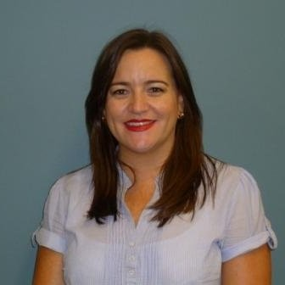

Phone: +61 2 9645 3692
Email: info@acrassoc.com.au
Web: www.acrassoc.com.au
Postal: PO Box 452, Chester Hill NSW 2162 Australia
ABN: 41 059 791 374
Australasian Concrete Repair & Remedial Building Association

