

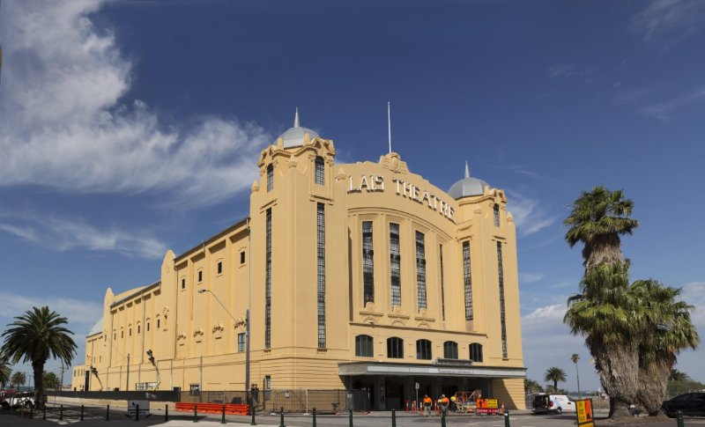

REMEDIAL INDUSTRY   
EXCELLENCE AWARDS

**SYDNEY February 2021**

ACRA setting the standards in remedial industry since 1991.

*Photo: 2018 ACRA Repair Industry Excellence Award*

***SRG Group – Palais Theatre, Victoria.***

**WELCOME TO YOUR 11TH BIENNIAL ACRA AWARDS**

Dear ACRA members,

The 11th biennial ACRA Awards will be held in February 2021 in Sydney.

Entries for the Biennial ACRA Remedial Industry Excellence Awards are now open!

2020 marks the first “Remedial Industry Excellence Awards”, where projects encompassing all facets of the remedial industry are invited to enter.  In previous years, concrete repair needed to be a major component of the works. The Remedial Industry Excellence awards now can be concrete repair, waterproofing, general refurbishment or other remedial works demonstrating the breadth of experience and project challenges in our industry.

ACRA’s Awards showcase our members' outstanding work in the remedial industry across a wide range of industries and market sectors – infrastructure, marine, residential, facilities, rail, water and roads to name a few.

We are looking for projects that are "Setting the Standards in Remedial Industry", and encourage entries from all project values, whether the project is a small but challenging $5,000 repair job or a $5,000,000 repair job.

Apart from entries to the Long-Term Performance Award for projects completed prior to June 2010, all other entries must have been completed in the 2yrs since 20 June 2018.

Winners will be announced at the ACRA Awards planned to be held in February 2021 in Sydney NSW.  Attached is your entry form and we also have this in fillable word format on request.   We look forward to receiving your entries and celebrating on the night.

ACRA had originally slotted the Awards night to take place in October 2020 but because of Covid-19 and to put our members and guests minds at ease we have decided to hold the award in February 2021, this means you now have breathing space to complete your applications as the **new deadline is Friday 16th of October 2020.**

Yours sincerely**Grahame Vile**

**ACRA President**

**EXPLANATION OF CATEGORIES**

The following is a guide to how the award categories are determined:

1. We will ask you to nominate the category(s) you believe the project fits into and the project value.
2. Once all entries are received, the awards committee will organise the entries into 'Award Categories' so that like projects compete with like projects. For example, the aim is that a $50,000 residential project will compete with projects of similar contract value and complexity.
3. Note that if insufficient entries are received in a particular category, then the entry may be combined into another similar category to compete with projects of similar size and complexity.
4. Some categories may not have enough entries and therefore that particular category may be excluded from the awards. For instance, if only one entry is received in one category it will most likely be combined with other dissimilar projects of similar size and complexity.
5. After the entries have been organised into Award Categories, the entrants will be notified what categories they have been placed into.
6. The entries and entrants will be promoted through our links in the industry, including the Australasian Corrosion Association, Concrete Institute of Australia, Strata Community Australia, ACRA website and other publications. They will then be submitted to our independent judging panel to determine the winners in each Award Category.
7. Final categories are at the judging committee’s sole discretion

The following categories are available:

**Category 1 – Investigation**

Entries are invited for excellence in the investigation and diagnosis of a remedial project. It may include processes used, selection of diagnostic testing, repair estimates and reporting methods.

**Category 2 – Research, Design and Innovation**

Entries are invited for innovation in all areas of remedial works.

Entries in Categories 1 and 2 will be judged principally on their significance to the investigation, design or innovation of concrete repair and protection technology, materials, systems or design to enable a project to be undertaken and completed successfully. Companies entering these categories should note some comments provided by the judging panel in previous years were:

- Investigation process

- Benefit to industry

- Potential for cost savings

- Potential for export of technology

- Originality

- Savings to project program

- Does the project support local research organisations and is there any evidence of team

working between industry and research? (Benefits to universities, CSIRO, etc)

- Cost analysis

- Uniqueness of the situation.

**Categories 3-9 - Commercial / Residential / Industrial / Marine / Heritage / Strengthening/Waterproofing**

In assessing the entries for Categories 3 to 9 the judges will take account of several factors held high in the ideals of ACRA. Judges will consider the overall project, its investigation, and remedial solution(s), innovative and economic treatment of the structure, with emphasis on the appropriateness of the solution to the requirements of the Client.

We are interested in specific references to the special ways in which the project was innovative or posed difficulty in execution, timing etc.

Companies entering these categories should note some comments provided by the judging panel in previous years. These were:

**Relevance -** Are the remedial solutions relevant to the function of the structure?

**Economy -** Are the remedial solutions economical compared with alternative repair techniques?

**Innovation -** Arethe remedial solutions clever in terms of making economies or saving time or using new technology?

**Difficulty -** Were there any constraints that made the project difficult?

**Aesthetics -** Was it considered in the case of a building or heritage structure?

**Client requirements -** Were the client requirements sufficiently addressed?

**Effect on occupants/users -** Were they sufficiently addressed?

**Use of sound engineering principles and practices -** What was the standard of prior investigation and analysis and design of the repairs?

**Environmental -** Any considerations given?

**Category 10 – Long-Term Performance**

Entries are invited for projects completed more than 7 years ago that have achieved long-term durability and performance.

Long-term testing and inspection records, client testimonials, and retention of aesthetics and overall serviceability or function of the structure being maintained are key requirements. Companies entering this category should note some comments provided by the judging panel in previous years were:

- Serviceability/function maintained

- Long-term testing records

- Long-term inspection records

- Client testimonies

- Retention of aesthetics

**Repair Industry Excellence Award**

It is open to the judges to present this award to an entry from any of the categories above which, through its outstanding achievement or contribution to the repair industry, promotes the goals of the association and its members.

*Please note that all entries in all categories will be judged for the “REPAIR INDUSTRY EXCELLENCE” award and this requires no extra application or fee. This award will only be given if the judges deem it appropriate.*

**REQUIREMENTS PRIOR TO SENDING**

The closing date for all entries will be at **midday on Friday 16 October 2020.**

There will be no exceptions to this rule.

All entries should be posted to:

**Attention: Nicole Raymond**

**Australasian Concrete Repair and Remedial Building Association**

**PO Box 452**

**Chester Hill NSW 2162**

**The cost of each project entry is $250.00.**

The final cost will be invoiced to the entrant based on the number of entries.

Projects shall be submitted electronically via USB or drop box file or Transfer File.

The entry shall include the following:

1. Completed entry form.
2. A 100 word (maximum) description of the project and its highlights which will be used for promotional purposes and read out on the awards night**. Do not exceed this please.**
3. Up to 10 selected photos which will be used for promotional purposes and read out on the awards night.
4. Relevant project drawings and/or documentation.
5. Up to 30 additional photos of your project in .JPG format.

These photos may also be used on the awards night and on the ACRA website and other ACRA promotions.

Entries submitted previously in 2004, 2006, 2008, 2010, 2014 & 2016, 2018 **will not be accepted again for the same category**. They can, however, be submitted for the Long-Term Performance category if completed more than 7 years ago.

Awards of merit will be awarded in each of the categories. More than one award of merit may be given in any category. A single award of excellence will be awarded in each of the categories if the judges consider the entry to be of a high enough standard to be worthy.

We would like to wish you all the very best with your entry submissions. If you have any comments or queries regarding the awards or the submissions, please do not hesitate to email us at [info@acrassoc.com.au](mailto:info@acrassoc.com.au) or phone (02) 9645 3692.

**Entry checklist**

| **ACRA Awards Entry Checklist for 2020** |
| --- |
| * Completed and signed entry form   Client approval obtained (if required)   * Short description of project (100 words) for use in publications and to be read out on the night * Photographs (High res recommended on USB or drop box link) * Payment by EFT or request invoice |  |

# **REGISTRATION FORM**

**Remedial Industry Excellence Awards**

**2020 Entry Form**

|  |  |
| --- | --- |
| **Company Trading Name** |  |
| **Authorised Contact Person** |  |
| **Company Postal Address** |  |
| **Business Telephone No.** |  |
| **Business Facsimile No.** |  |
| **Email** |  |

|  |  |  |
| --- | --- | --- |
| **Project Title** |  | |
| **Address of Project** |  | |
| **Total Project Value** |  | |
| **Remedial Works Components and $ Values** | * Concrete Repair: Value__________________ * Remedial Waterproofing: Value__________________ * Remedial Building Works: Value__________________ * Other_____________________Value__________________ | |
| **Categories** | Nominate up to three (3) category(s) you believe the project fits into. Note that the Awards Committee has final discretion as to the Category the project is entered into. | |
| * Investigation and diagnosis * Research, Design and Innovation * Commercial * Residential * Industrial * Marine * Heritage structures * Strengthening * Long term performance | * Buildings * Wharves * Bridges * Water and sewer * Mega projects >$10M * Small project <$100K * Supply * Other * ______________________ |
| **Client** |  | |
| **Consultant(s)** |  | |
| **Contractor(s)** |  | |
| **Supplier(s)** |  | |

*Only contributions of Corporate ACRA members will be mentioned on the awards evening*

**Your Project Description**

Provide a brief outline of the project in up to 250 words for each of the following sections

|  |  |  |
| --- | --- | --- |
| **Short 100-word description of entry which will be used in publications and on the night of the awards** |  | |
| **Project Completion Date** |  | |
| **Background / History of Project** |  | |
| **Were other ACRA members Involved?** |  | |
| **What investigations were carried out?** |  | |
| **How was the project tendered/awarded** |  |
| **Outline any particular constraints/difficulties** |  |
| **How were the above overcome?** |  |
| **Did the project add extra value for the client?** |  |
| **How were estimates, costs and quantities handled, and were they within expectations?** |  |
| **Client referee contact details.** |  |
| **Other information** |  |